From DATE : 14.12.2020
K. Venugopalan, B.Com .,B.L.,
Advocate
Legal & Management Consultant,
S-5, 2nd floor, MM. Bhavanam,
No: 11 (Near Chockanathar Koil), 2nd Street,
Chockalinga Nagar, Madurai – 625 010.

To
The Head Of the Department (HOD),
Department of Information Technology
The American College, Madurai – 625 002.

Sir,
REF : L. Rohith Viswa, B.Sc (IT), Madurai/ Roll No: 17BIT54
SUB : Information regarding his employment

o-o-o

In respect of the above student, I wish to inform your goodselves that Selvan. L. Rohith Viswa, who has completed his B.Sc., (IT) in the year 2020. Presently he is engaged in my office as a Trainee – Data Entry Operator.

This communication is given to your department on his request to communicate the fact that he is
employed in my office as a trainee.

Thanking you,

Yours Sincerely,
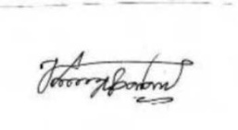
(K. VENUGOPALAN)

