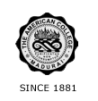
THE AMERICAN COLLEGE, MADURAI
(An Autonomous Institution Affiliated to Madurai Kamaraj University)
Re-accredited (2nd Cycle) by NAAC with Grade “A” CGPA – 3 .46 on a 4 - point scale

SSR Cycle – 3
Criterion – V Student Support and Progression
5.1 Student Support

1. Career Opportunities 26.07.16

I. Job Opportunities in Banking Sector 08.02.17

