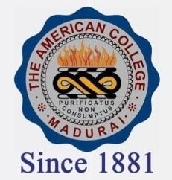
THE AMERICAN COLLEGE, MADURAI
(An Autonomous Institution Affiliated to Madurai Kamaraj University)
Re-accredited (2nd Cycle) by NAAC with Grade “A” CGPA-3.46 on a 4 point scale

SSR Cycle – 3

Criterion – V – Student Support & Progression

5.1 Student Support
5.1.2. Link to relevant documents of scholarships and freeships Institution

2019-2020
a. SPORTS SCHOLARSHIP
b. EARN-WHILE-LEARN
c. LUNCH ASSISTANCE PROGRAMME
d. ENDOWNMENT CASH SCHOLARSHIP
e. PDF NTS
f. PDF STUDENTS

