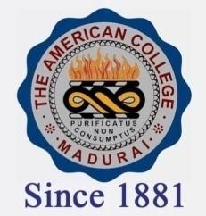
THE AMERICAN COLLEGE, MADURAI
(An Autonomous Institution Affiliated to Madurai Kamaraj University)
Re-accredited (2nd Cycle) by NAAC with Grade “A” CGPA-3.46 on a 4 point scale

SSR Cycle – 3

Criterion – V – Student Support & Progression

5.1 Student Support
5.1.2. Copy of Sanction letters of Scholarships and freeships Institutions & NGO’s

DVV

- SPORTS SCHOLARSHIP
- 2019-2020
- 2018-2019
- 2017-2018
- 2016-2017
e) 2015-2016
- EARN-WHILE-LEARN
- 2019-2020
- 2018-2019
- 2017-2018
- 2016-2017

- LUNCH ASSISTANCE PROGRAMME
- 2019-2020
b) 2018-2019
- ENDOWNMENT CASH SCHOARSHIP
- 2019-2020
- 2018-2019
- 2017-2018
- 2016-2017

