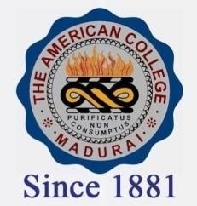
THE AMERICAN COLLEGE, MADURAI
(An Autonomous Institution Affiliated to Madurai Kamaraj University)
Re-accredited (2nd Cycle) by NAAC with Grade “A” CGPA-3.46 on a 4 point scale

SSR Cycle – 3

Criterion – V – Student Support & Progression

5.1 Student Support
5.1.1. Link to relevant documents of scholarships and freeships of Government (National)

2018-2019
a. SC/ST SCHOLARSHIP
b. BC/MBC SCHOLARSHIP
c. SPECIAL SCHOLARSHIP
d. MINORITY SCHOLARSHIP

