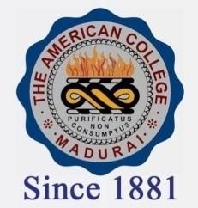
THE AMERICAN COLLEGE, MADURAI
(An Autonomous Institution Affiliated to Madurai Kamaraj University)
Re-accredited (2nd Cycle) by NAAC with Grade “A” CGPA-3.46 on a 4 point scale

SSR Cycle – 3

Criterion – V – Student Support & Progression

5.1 Student Support
5.1.1. Link to relevant documents of scholarships and freeships of Government (National)
EXCEL

- 2019-2020
- SC/ST SCHOLARSHIP
- BC/MBC SCHOLARSHIP
- SPECIAL SCHOLARSHIP
- MINORITY SCHOLARSHIP
- 2018-2019
  - SC/ST SCHOLARSHIP
  - BC/MBC SCHOLARSHIP
  - SPECIAL SCHOLARSHIP
  - MINORITY SCHOLARSHIP
- 2017-2018
  - SC/ST SCHOLARSHIP
  - BC/MBC SCHOLARSHIP
  - SPECIAL SCHOLARSHIP
  - MINORITY SCHOLARSHIP
- 2016-2017
  - SC/ST SCHOLARSHIP
  - BC/MBC SCHOLARSHIP
  - SPECIAL SCHOLARSHIP
  - TAMIL MEDIUM SCHOLARSHIP
  - MINORITY SCHOLARSHIP
- 2015-2016
  - SC/ST SCHOLARSHIP
  - BC/MBC SCHOLARSHIP
  - SPECIAL SCHOLARSHIP
  - TAMIL MEDIUM SCHOLARSHIP
  - MINORITY SCHOLARSHIP

