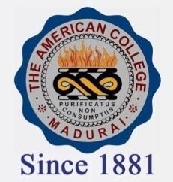
THE AMERICAN COLLEGE, MADURAI
(An Autonomous Institution Affiliated to Madurai Kamaraj University)
Re-accredited (2nd Cycle) by NAAC with Grade “A” CGPA-3.46 on a 4 point scale

SSR Cycle – 3

Criterion – V – Student Support & Progression

5.1 Student Support
5.1.1. Copy of Sanction letters of scholarships and freeships of Government
DVV
- SC/ST SCHOLARSHIP
A. 2019-2020
B. 2018-2019
C. 2017-2018
D. 2016-2017
E. 2015-2016

2. BC/MBC SCHOLARSHIP
A. 2019-2020
B. 2018-2019
C. 2017-2018
D. 2016-2017
E. 2015-2016

- SPECIAL SCHOLARSHIP
A. 2019-2020
B. 2018-2019
C. 2017-2018
D. 2016-2017
E. 2015-2016

- TAMIL MEDIUM SCHOLARSHIP
A. 2017-2018
B. 2016-2017
C. 2015-2016

- MINORITY SCHOLARSHIP
A.2019-2020
B. 2018-2019
C. 2017-2018
D. 2016-2017
E. 2015-2016

