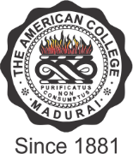

THE AMERICAN COLLEGE
(An Autonomous Institution Affiliated to Madurai Kamaraj University)
Re-accredited (2nd Cycle) by NAAC with Grade “A” CGPA – 3 .46 on a 4 - point scale

MADURAI - 625002

SSR Cycle – 3

Criterion I – Curricular Aspects
1.3 Curriculum Enrichment

1.3.2 List of value Added Courses

