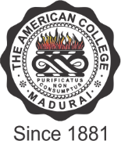

THE AMERICAN COLLEGE
(An Autonomous Institution Affiliated to Madurai Kamaraj University)
Re-accredited (2nd Cycle) by NAAC with Grade “A” CGPA – 3 .46 on a 4 - point scale
MADURAI - 625002

SSR Cycle – 3
Criterion I – Curricular Aspects
1.1. Curriculum Design and Development

Additional Documents - 1.1.2

File Name | Link to the Description
Minutes of Academic Council and Boards of Studies | 
Programmes offered by the Institution - Yearwise | 
Certificate from the Chairperson of Board of Studies
Advertisements – Yearwise

