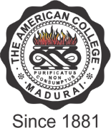

THE AMERICAN COLLEGE
(An Autonomous Institution Affiliated to Madurai Kamaraj University)
Re-accredited (2nd Cycle) by NAAC with Grade “A” CGPA – 3 .46 on a 4 - point scale
MADURAI - 625002

SSR Cycle – 3
Criterion I – Curricular Aspects
1.1. Curriculum Design and Development

Additional Documents – 1.1.2

File Name | Link to the Description
Vision and Mission of the Institution | 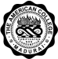
Hierarchy of the Curriculum Design and Development
Mapping of Curriculum POs, PSOs, with relevance to
Local, National, Regional, Global
Programme Outcomes (POs) – Research, Postgraduate,
Undergraduate Programmes
Programme Specific Outcomes(PSOs) – Research Programmes
Programme Specific Outcomes(PSOs) – Postgraduate
Programmes
Programme Specific Outcomes(PSOs) – Undergraduate
Programmes
Course Outcomes(COs) – Research Programmes
Course Outcomes(COs) – Postgraduate Programmes
Course Outcomes(COs) – Undergraduate Programmes

