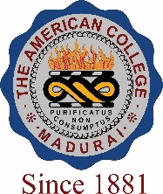
THE AMERICAN COLLEGE, MADURAI
(An Autonomous Institution Affiliated to Madurai Kamaraj University)
Re-accredited (2nd Cycle) by NAAC with Grade “A” CGPA – 3 .46 on a 4 - point scale

SSR Cycle – 3
Criterion VII – Institutional values and Best Practices
7.1 Institutional Values and Social Responsibilities
7.1.7 The institution has disabled-friendly, barrier free environment

1. Built environment with ramps/lifts for easy access to classrooms.

2. Disabled-friendly washrooms

3. Signage including tactile path, lights, display boards and signposts

4. Assistive technology and facilities for persons with disabilities (Divyangjan) accessible website, screen-reading software, mechanized equipment

5. Provision for enquiry and information: Human assistance, reader, scribe, soft copies of reading material, screen reading

Options:
- Any 4 or all the above
- Any 3 of the above
- Any 2 of the above
- Any 1 of the above
- None of the above.

Response: A. Any 4 or all of the above

