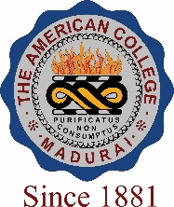
THE AMERICAN COLLEGE, MADURAI
(An Autonomous Institution Affiliated to Madurai Kamaraj University)
Re-accredited (2nd Cycle) by NAAC with Grade “A” CGPA – 3 .46 on a 4 - point scale

SSR Cycle – 3
Criterion VII – Institutional values and Best Practices
7.1 Institutional Values and Social Responsibilities

7.1.5 Green campus initiatives:

- Restricted entry of automobiles

- Use of Battery powered vehicle
- Pedestrian friendly pathway
- Ban on use of plastic
- Landscaping with trees and plants
Options:
- Any 4 or All the above
- Any 3 of the above
- Any 2 of the above
- Any 1 of the above
- None of the above
Response: A

