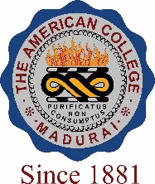
THE AMERICAN COLLEGE, MADURAI
(An Autonomous Institution Affiliated to Madurai Kamaraj University)
Re-accredited (2nd Cycle) by NAAC with Grade “A” CGPA – 3 .46 on a 4 - point scale

SSR Cycle – 3
Criterion VII – Institutional values and Best Practices
7.1 Institutional Values and Social Responsibilities

7.1.4 Water conservation facilities available in the institution:

- Rain water harvesting

- Borewell/ Open well recharge

- Construction of tank sand bunds

- Waste water recycling

- Maintenance of water bodies and distribution system in the campus
Options:
- All 4 and above
- Any 3 of the above
- Any 2 of the above
- Any 1 of the above
- None of the above
Response: A

