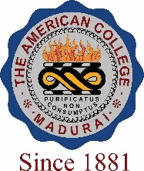
THE AMERICAN COLLEGE, MADURAI
(An Autonomous Institution Affiliated to Madurai Kamaraj University)
Re-accredited (2nd Cycle) by NAAC with Grade “A” CGPA – 3 .46 on a 4 - point scale

SSR Cycle – 3
Criterion VII – Institutional values and Best Practices
7.1 Institutional Values and Social Responsibilities

7.1.2 The Institution has facilities for alternate sources of energy and energy conservation measures

- Solar Energy

- Biogas Plant
- Wheeling to the Grid
- Sensor-based energy conservation

- Use of LED bulbs/power efficient equipment
Options:
- Any 4 or All of the above
- Any 3 of the above
- Any 2 of the above
- Any 1 of the above
- None of the above
Response: A

