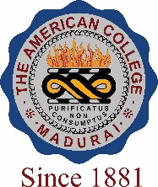
THE AMERICAN COLLEGE, MADURAI
(An Autonomous Institution Affiliated to Madurai Kamaraj University)
Re-accredited (2nd Cycle) by NAAC with Grade “A” CGPA – 3 .46 on a 4 - point scale

SSR Cycle – 3
Criterion VII – Institutional values and Best Practices
7.1 Institutional Values and Social Responsibilities

7.1.10 The Institution has a prescribed code of conduct for students, teachers, administrators and other staff and conducts periodic programmes in this regard

7.1.10 The Institution has a prescribed code of conduct for students, teachers, administrators
and other staff and conducts periodic programmes in this regard.

- The Code of Conduct is displayed on the website

- There is a committee to monitor adherence to the Code of Conduct
- Institution organizes professional ethics programmes for students, teachers,

administrators and other staff
- Annual awareness programmes on Code of Conduct are organized

Options:
- All of the above
- Any 3 of the above
- Any 2 of the above
- Any 1 of the above
- None of the above
Response: All of the above

