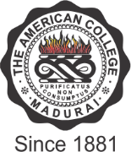

THE AMERICAN COLLEGE
(An Autonomous Institution Affiliated to Madurai Kamaraj University)
Re-accredited (2nd Cycle) by NAAC with Grade “A” CGPA – 3 .46 on a 4 - point scale
MADURAI - 625002
SSR Cycle – 3
Criterion V – Student Support and Progression
5.4. Alumni Engagement

5.4.2 Q_{n}M

Alumni financial contribution during the last five years (in INR)

Options:
- ≥ 15 Lakhs Rs. 28,72,551.00
- 10Lakhs - 15 Lakhs
- 5 Lakhs - 10 Lakhs
- 2 Lakhs - 5 Lakhs
- <2 Lakhs

