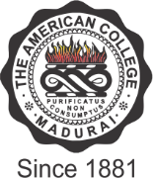

THE AMERICAN COLLEGE
(An Autonomous Institution Affiliated to Madurai Kamaraj University)
Re-accredited (2nd Cycle) by NAAC with Grade “A” CGPA – 3 .46 on a 4 - point scale
MADURAI - 625002
SSR Cycle – 3
Criterion V – Student Support and Progression
5.3. Student Participation and Activities

QnM 5.3.1
Number of awards/medals for outstanding performance in sports/cultural activities
Number of awards/medals for outstanding performance in sports/cultural activities at inter-university / state /national / international level (award for a team event should be counted as one) year wise during last five years

Year | 2019 -2020 | 2018 – 2019 | 2017 -2018 | 2016 – 2017 | 2015 - 2016
Number | 90 | 120 | 61 | 25 | 42

