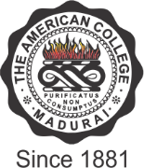

THE AMERICAN COLLEGE
(An Autonomous Institution Affiliated to Madurai Kamaraj University)
Re-accredited (2nd Cycle) by NAAC with Grade “A” CGPA – 3 .46 on a 4 - point scale

MADURAI - 625002
SSR Cycle – 3
Criterion V – Student Support and Progression
5.2. Student Progression

Average percentage of placement of outgoing students during the last five years

: Number of outgoing students placed year wise during last five years
Year | 2019-2020 | 2018-2019 | 2017-2018 | 2016-2017 | 2015-2016
Number | 358 | 180 | 224 | 168 | 137

Data Requirement for last five years: (As per Data Template)

        - Name of the employer with contact details
        - Number of students placed Formula:

Percentage per year =

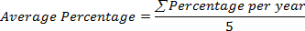
=
File Description (Upload)

        - Self attested list of students placed
        - Upload any additional information
Details of student placement during the last five years(Data Template)

