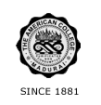
THE AMERICAN COLLEGE, MADURAI
(An Autonomous Institution Affiliated to Madurai Kamaraj University)
Re-accredited (2nd Cycle) by NAAC with Grade “A” CGPA – 3 .46 on a 4 - point scale

SSR Cycle – 3
Criterion – V Student Support and Progression
5.1 Student Support

5.1.2 Details of Scholarship and Freeships by Institution

QnM 5.1.2 Metric Data: (Table of year wise number)

Average percentage of students benefited by scholarships, freeships, etc. provided by the institution and non-government agencies during the last five years

Total number of students benefited by scholarships, freeships, etc provided by the institution and non-government agencies year wise during last five years

Year | 2019-2020 | 2018-2019 | 2017-2018 | 2016-2017 | 2015-2016
Number | 261 | 123 | 164 | 80 | 86

Formula:

Percentage per year = 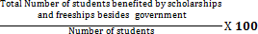

2019-20 % = 254/8704 = 2.91%
2018-19 % = 123/7699 = 1.60%
2017-18 % = 168/6777 = 2.48%
2016-17 % = 80/6142 = 1.30%
2015-16 % = 86/ 5384 = 1.60%

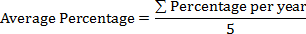
= 1.98 %

