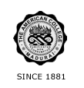
THE AMERICAN COLLEGE, MADURAI
(An Autonomous Institution Affiliated to Madurai Kamaraj University)
Re-accredited (2nd Cycle) by NAAC with Grade “A” CGPA – 3 .46 on a 4 - point scale

SSR Cycle – 3
Criterion – V Student Support and Progression
5.1 Student Support
5.1.1 Details of Scholarship and Freeships by Government

5.1.1 Q_{n}M Metric Data: (Table of year wise number)

Average percentage of students benefited by scholarships and freeships provided by the Government during the last five years

Number of students benefited by scholarships and freeships provided by the Government year wise during last five years

Year | 2019-2020 | 2018-2019 | 2017-2018 | 2016-2017 | 2015-2016
Number | 631 | 740 | 848 | 1099 | 1050

Formula:

Percentage per year = 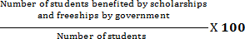

2019-20 % = 631/8704 = 7.24%
2018-19 % = 740/7699 = 9.61 %
2017-18 % = 848/6777 = 12.52%
2016-17 % = 1099/6142 = 17.89%
2015-16 % = 1050/ 5384 = 19.50%

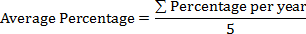

= 66.74/5 = 13.35%

