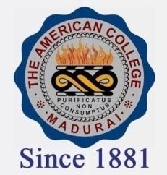
THE AMERICAN COLLEGE, MADURAI
(An Autonomous Institution Affiliated to Madurai Kamaraj University)
Re-accredited (2nd Cycle) by NAAC with Grade “A” CGPA-3.46 on a 4 point scale

SSR Cycle – 3

Criterion – III Research, Innovations and Extension

3.6 Extension activities

3.6.4.1: Total number of students participating in extension activities with Government Organisations, Non-Government Organisations and Programmes such as Swachh Bharat, Aids Awareness, Gender Issue, etc. year wise during last five years

Year | 2019-2020 | 2018-2019 | 2017-2018 | 2016-2017 | 2015-2016
Number | 7520 | 7021 | 6590 | 5329 | 4602

