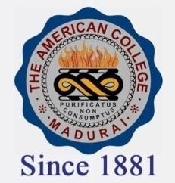
THE AMERICAN COLLEGE, MADURAI
(An Autonomous Institution Affiliated to Madurai Kamaraj University)
Re-accredited (2nd Cycle) by NAAC with Grade “A” CGPA-3.46 on a 4 point scale

SSR Cycle – 3

Criterion –III Research, Innovations and Extension

3.6 Extension activities

3.6.3.1: Number of extension and outreach programs conducted in collaboration with industry, community and Non-Government Organisations through NSS/NCC/Red cross/YRC etc., year wise during last five years

Year | 2019-2020 | 2018-2019 | 2017-2018 | 2016-2017 | 2015-2016
Number | 610 | 584 | 602 | 250 | 274

