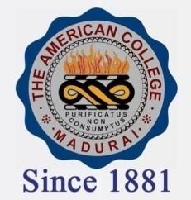
THE AMERICAN COLLEGE, MADURAI
(An Autonomous Institution Affiliated to Madurai Kamaraj University)
Re-accredited (2nd Cycle) by NAAC with Grade “A” CGPA-3.46 on a 4 point scale

SSR Cycle – 3

Criterion – III – Research, Innovations and Extension

3.6 Extension activities

3.6.2.1: Total number of awards and recognition received for extension activities from Government /recognised bodies year wise during last five years

Year | 2019-2020 | 2018-2019 | 2017-2018 | 2016-2017 | 2015-2016
Number | 23 | 14 | 8 | 17 | 19

