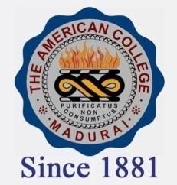
THE AMERICAN COLLEGE, MADURAI
(An Autonomous Institution Affiliated to Madurai Kamaraj University)
Re-accredited (2nd Cycle) by NAAC with Grade “A” CGPA-3.46 on a 4 point scale

SSR Cycle – 3

Criterion – III Research, Innovations and Extension

3.5 Consultancy

3.5.1.1: Total amount generated from consultancy and corporate training year wise during last five years (INR in lakhs)
Year | 2019-2020 | 2018-2019 | 2017-2018 | 2016-2017 | 2015-2016
INR in lakhs | 0.16 | 0.20 | 0.07 | - | -

