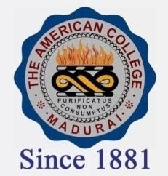
THE AMERICAN COLLEGE, MADURAI
(An Autonomous Institution Affiliated to Madurai Kamaraj University)
Re-accredited (2nd Cycle) by NAAC with Grade “A” CGPA-3.46 on a 4 point scale

SSR Cycle – 3

Criterion – III Research, Innovations and Extension

3.4.4 Books and Proceedings – 2019-2015

2019 | 2018 | 2017 | 2016 | 2015

