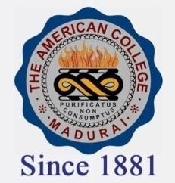
THE AMERICAN COLLEGE, MADURAI
(An Autonomous Institution Affiliated to Madurai Kamaraj University)
Re-accredited (2nd Cycle) by NAAC with Grade “A” CGPA-3.46 on a 4 point scale

SSR Cycle – 3

Criterion – III Research, Innovations and Extension

3.4 Research Publications and Awards

3.4.2.1: How many Ph.Ds are registered within last 5 years : 83

3.4.2.2 : Number of teachers recognized as guides during :19
the last five years

