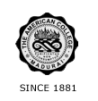
THE AMERICAN COLLEGE, MADURAI
(An Autonomous Institution Affiliated to Madurai Kamaraj University)
Re-accredited (2nd Cycle) by NAAC with Grade “A” CGPA – 3 .46 on a 4 - point scale

SSR Cycle – 3

Criterion III –Research, Innovations and Extension

3.4 Research Publications and Awards

3.4.2 URL to the research page on the College website (Link)

