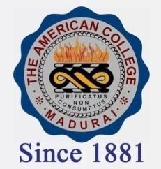
THE AMERICAN COLLEGE, MADURAI
(An Autonomous Institution Affiliated to Madurai Kamaraj University)
Re-accredited (2nd Cycle) by NAAC with Grade “A” CGPA-3.46 on a 4 point scale

SSR Cycle – 3

Criterion – III Research, Innovations and Extension

3.3 Innovation Ecosystem

3.3.2.1: Total number of workshops/seminars conducted on Research Methodology, Intellectual Property Rights (IPR) and entrepreneurship and skills development year wise during last five years
Year | 2019-20 | 2018-19 | 2017-18 | 2016-17 | 2015-16
Number | 407 | 49 | 43 | 22 | 15

