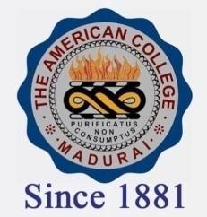
THE AMERICAN COLLEGE, MADURAI
(An Autonomous Institution Affiliated to Madurai Kamaraj University)
Re-accredited (2nd Cycle) by NAAC with Grade “A” CGPA-3.46 on a 4 point scale

SSR Cycle – 3

Criterion – III Research, Innovations and Extension

3.2 Resource Mobilization for Research.

3.2.4.1: Number of departments having Research projects funded by government and non-government agencies during the last five years
Year | 2019-20 | 2018-19 | 2017-18 | 2016-17 | 2015-16
Number | 5 | 7 | 10 | 5 | 4

