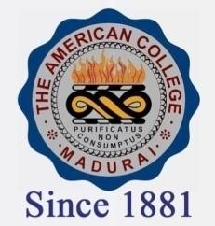
THE AMERICAN COLLEGE, MADURAI
(An Autonomous Institution Affiliated to Madurai Kamaraj University)
Re-accredited (2nd Cycle) by NAAC with Grade “A” CGPA-3.46 on a 4 point scale

SSR Cycle – 3

Criterion – III Research, Innovations and Extension

3.2 Resource Mobilization for Research

3.2.3.1: Number of teachers recognised as research guides: 46

