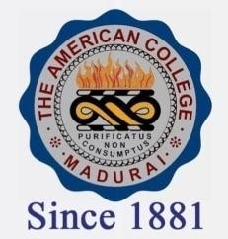
THE AMERICAN COLLEGE, MADURAI
(An Autonomous Institution Affiliated to Madurai Kamaraj University)
Re-accredited (2nd Cycle) by NAAC with Grade “A” CGPA-3.46 on a 4 point scale

SSR Cycle – 3

Criterion – III Research, Innovations and Extension

3.2 Resource Mobilization for Research.

3.2.2.1: Number of teachers having research projects during the last five years
Year | 2019-2020 | 2018-2019 | 2017-2018 | 2016-2017 | 2015-2016
Number of teachers having research projects | 11 | 11 | 21 | 8 | 6

