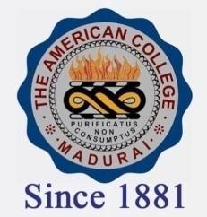
THE AMERICAN COLLEGE, MADURAI
(An Autonomous Institution Affiliated to Madurai Kamaraj University)
Re-accredited (2nd Cycle) by NAAC with Grade “A” CGPA-3.46 on a 4 point scale

SSR Cycle – 3

Criterion – III Research, Innovations and Extension

3.2 Resource Mobilization for Research.

3.2.1.1: Total Grants from Government and non-governmental agencies for research projects ,
endowments, Chairs in the institution during the last five years (INR in Lakhs)

Year | 2019-2020 | 2018-2019 | 2017-2018 | 2016-2017 | 2015-2016
INR in Lakhs | 19.57 | 28.40 | 153.05 | 19.60 | 43.76

