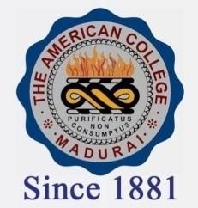
THE AMERICAN COLLEGE, MADURAI
(An Autonomous Institution Affiliated to Madurai Kamaraj University)
Re-accredited (2nd Cycle) by NAAC with Grade “A” CGPA-3.46 on a 4 point scale

SSR Cycle – 3

Criterion – III Research, Innovations and Extension

3.1 Promotion of Research and Facilities
.

3.1.3.1: The number of teachers awarded national/international fellowship for advanced studies / research year wise during last five years
Year | 2019-2020 | 2018-2019 | 2017-2018 | 2016-2017 | 2015-2016
Number of teachers | - | 1 | 5 | 3 | 1

