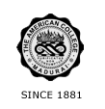
THE AMERICAN COLLEGE, MADURAI
(An Autonomous Institution Affiliated to Madurai Kamaraj University)
Re-accredited (2nd Cycle) by NAAC with Grade “A” CGPA – 3 .46 on a 4 - point scale

SSR Cycle – 3
Criterion 2 – Teaching Learning and Evaluation

2.6. Student Performance and Learning Outcomes

Pass percentage of students (Data for the latest completed academic year 2019-20)
- : Total number of final year students who passed the examination conducted by Institution | 1970
2.6.3.2: Total number of final year students who appeared for the examination | 2356
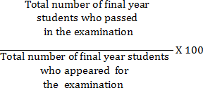
Pass percentage of students = 83.62

