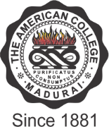

THE AMERICAN COLLEGE
(An Autonomous Institution Affiliated to Madurai Kamaraj University)
Re-accredited (2nd Cycle) by NAAC with Grade “A” CGPA – 3 .46 on a 4 - point scale

MADURAI - 625002

SSR Cycle – 3

Criterion I – Curricular Aspects
1.3 Curriculum Enrichment

Metric-1.3.4.Percentage of students undertaking field projects/internships/student projects (Data for the latest completed academic year)

1.3.4.1: Number of students undertaking field projects/internships/student projects:
Response: 1208

