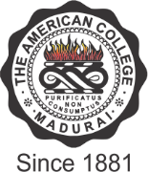

THE AMERICAN COLLEGE
(An Autonomous Institution Affiliated to Madurai Kamaraj University)
Re-accredited (2nd Cycle) by NAAC with Grade “A” CGPA – 3 .46 on a 4 - point scale

MADURAI - 625002

SSR Cycle – 3

Criterion I – Curricular Aspects
1.3 Curriculum Enrichment

1.3.2: Number of value added courses for imparting transferable and life skills offered during last five years
Response: 20

1.3.3 Average percentage of students enrolled in the courses in1.3.2
1.3.3.1: Number of students enrolled in value added courses (beyond the curriculum) offered year wise during last five years:
2019-2020 | 2018-2019 | 2017-2018 | 2016-2017 | 2015-2016
2774 | 2689 | 1652 | 1549 | 1305

