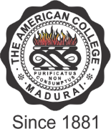

THE AMERICAN COLLEGE
(An Autonomous Institution Affiliated to Madurai Kamaraj University)
Re-accredited (2nd Cycle) by NAAC with Grade“A” CGPA – 3 .46 on a 4 - point scale
MADURAI - 625002

SSR Cycle – 3

Criterion I – Curricular Aspects
1.1 Curriculum Design and Development

    - Average percentage of courses having focus on employability/entrepreneurship/ skill development offered by the institution during the last five years:

      - : Number of courses having focus on employability/ entrepreneurship / skill development offered by the institution during the last five years

Year | 2019-20 | 2018-19 | 2017-18 | 2016-17 | 2015-16
No. of Courses | 576 | 497 | 489 | 447 | 439

