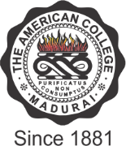

THE AMERICAN COLLEGE
(An Autonomous Institution Affiliated to Madurai Kamaraj University)
Re-accredited (2nd Cycle) by NAAC with Grade “A” CGPA – 3 .46 on a 4 - point scale

MADURAI - 625002

SSR Cycle – 3

Criterion I – Curricular Aspects

Percentage of programmes where syllabus revision was carried out
during the last five years

Criteria – 1.1.2.1
How many programmes were revised out of total number of programmes offered during the same period within the last five years - 59

Criteria – 1.1.2.2
Number of all Programmes offered by the institution during the last five years

2019 | 2018 | 2017 | 2016 | 2015
60 | 60 | 56 | 51 | 49

Formula
Number of programs in which syllabus was revised
during the last five years
___________________________________________ X 100
Total number of programmesoffered by the institution
during the last five years

58
________________ X 100 = 96.6 %
60

